**Demonstrate installation and configuration of AutoIT**

Step 1: Goto this page

<https://www.autoitscript.com/site/autoit/downloads/>

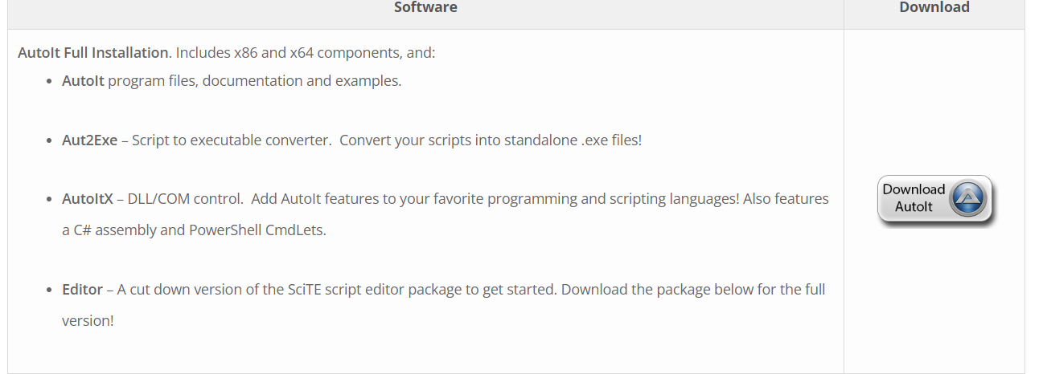



Step 2: Download Autoit and Editor



Step 3: extract autoit zip



Step 4: click and install

Step 5: also install SciTE4AutoIt3